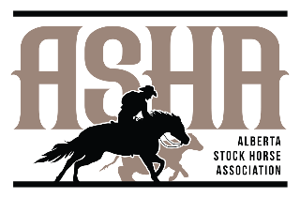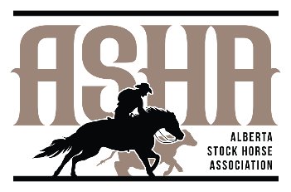**2025**

**Alberta Stock Horse Association**

**Class Fees**

**NRCHA Horse Show Fees**

|  |  |  |  |  |  |  |
| --- | --- | --- | --- | --- | --- | --- |
| Class Number | Class | Added Money | Add Back | Judge Cattle Office | NRCHA Fee | Total Entry Fee |
| 30 | Open Bridle | $250 | $60 | $123 | $14 | $197 |
| 31 | Intermediate Open Bridle |  | $60 | $51 | $14 | $125 |
| 32 | Limited Open Bridle |  | $60 | $123 | $14 | $197 |
| 33 | Non Pro Bridle | $100 | $60 | $123 | $14 | $197 |
| 34 | Intermediate Non Pro Bridle | $50 | $60 | $123 | $14 | $197 |
| 35 | Limited Non Pro Bridle | $100 | $60 | $123 | $14 | $197 |
| 36 | Select Non Pro Bridle |  | $60 | $22 | $14 | $96 |
| 37 | Open Hackamore | $250 | $60 | $123 | $14 | $197 |
| 38 | Intermediate Open Bridle |  | $60 | $51 | $14 | $122 |
| 39 | Limited Open Hackamore |  | $60 | $51 | $14 | $125 |
| 40 | Non Pro Hackamore |  | $60 | $123 | $14 | $197 |
| 41 | Open Two Rein | $50 | $60 | $123 | $14 | $197 |
| 42 | Non Pro Two Rein | $50 | $60 | $123 | $14 | $197 |
| 43 | Youth Cow Horse | $50 | $35 | $62 | $14 | $111 |
| 44 | Youth Cow Horse 13 & under |  | $35 | $17 | $14 | $66 |
| 45 | Box Drive |  | $60 | $96 | $14 | $170 |
| 46 | Non Pro Boxing | $50 | $60 | $96 | $14 | $170 |
| 47 | Intermediate Non Pro Boxing | $50 | $60 | $108 | $14 | $181 |
| 48 | Select Non Pro Boxing |  | $60 | $22 | $14 | $96 |
| 49 | Limited Non Pro Boxing |  | $60 | $108 | $14 | $182 |
| 50 | Youth Boxing |  | $35 | $62 | $14 | $111 |
| 51 | Youth Boxing 13 & Under |  | $35 | $12 | $14 | $61 |

**OTHER FEES**:

|  |  |  |  |  |  |  |  |
| --- | --- | --- | --- | --- | --- | --- | --- |
| Stalls – 2 Nights | $90 |  | 2025 Membership Fee - Adult | $50 |  | Practice Pen - Herd | $115 |
| Stalls – 3 Nights | $120 |  | 2025 Membership Fee - Family | $100 |  | Practice Pen - Fence | $80 |
| Camping/Night | $35 |  | 2025 Membership Fee - Youth | $21 |  | Late Fee for Horse Show | $200 |

**EXTRAS**:

* See show terms & conditions sheet for more information.
* Competitors can enter ASHA classes, NRCHA classes, or both.
* Youth classes: competitors that are entered in class 44 must also be entered in class 43. Youth that are entered in 51 must also be entered in 50.
* “Youth Bridle” as a class no longer exists. The class is now Youth Cow Horse. Youth are not required to just show in a bridle, youth can show in horse age-appropriate headgear. Hackamore, Two Rein, Snaffle for 5 and under – all are eligible! Less limiting for intrepid youth kids.
* NRCHA classes that are being offered will be listed on the online entry form on the website.

*Cheques payable to Ponoka Ag Society

*e transfers taken prior to show, once invoice has been received (abstockhorse1@gmail.com)

*Cash

*CC with 4% added to invoice